**INTERNET OF THING FOR SMART CITIES**



Arranged by :

|  |  |
| --- | --- |
| Gading Aulia | 2041160028 |
| Saniyya Tabrisa Imany | 2041160146 |
| Susi Susanti | 2041160041 |

**DIGITAL TELECOMMUNICATIONS NETWORKS**

**STUDY PROGRAM**

**ELECTRICAL ENGINEERING**

**STATE POLYTECHNIC OF MALANG**

**2021**

**ABSTRACT**

Smart door is designed to increase security in a building or home, where the system will detect the movement of a door with a password. The password will be entered through the blynk application, which if the password is entered correctly, the door will automatically open and the PIR sensor will detect movement to turn on the light switch in the room. If the password is entered incorrectly then (real:alarm) will sound. From the results of experiments that have been carried out, the success obtained is 70% more accurate and strengthens the security system in a building or house.

# CONTENTS

COVER PAGE

ABSTRACT ii

CONTENTS iii

1. INTRODUCTION……………………………………………………...…………………...1

1.1 Initial Scope………………………………………………………………..…………...1

1.2 Final Scope………………………………………………………….………………….1

1.3 Goal…………………………………………………………………………………….2

2. BACKGROUND………………………………………………….………………………3

2.1 Smart Cities……………………………………………………..……….……………..3

2.2 Sensors…………………………………………………………………....……………4

2.3 WiFi…………………………………………………………………….….…………..4

3. ARCHITECTURE ………………………………………………………………….…...12

3.1 Diagram Block………………………………………………………………….….…..6

3.2 FLowchart……………………………………………………………………….….….7

4. IMPLEMTATION ………………………………..…………………………………....…..8

5. RESULT…………………………………………………………………………………...10

6. CONCLUTION………………………………………………………………..………….11

7. REFRENCE 12

# SECTION 1

## INTRODUCTION

A smart lock is an [electromechanical](https://en.wikipedia.org/wiki/Electromechanics) [lock](https://en.wikipedia.org/wiki/Lock_(security_device)) which is designed to perform locking and unlocking operations on a door when it receives such instructions from an authorized device using a wireless protocol and a [cryptographic key](https://en.wikipedia.org/wiki/Cryptographic_key) to execute the authorization process. It also monitors access and sends alerts for the different events it monitors and some other critical events related to the status of the device. Smart locks can be considered part of a [smart home](https://en.wikipedia.org/wiki/Smart_home).

Most smart locks are installed on mechanical locks (simple types of locks, including [deadbolts](https://en.wikipedia.org/wiki/Deadbolt)) and they physically upgrade the ordinary lock. Recently, smart locking controllers have also appeared at the market.

* 1. **Initial scope**

The initial aim of the project was to conduct experiments with the ultimate goal of implementation smart door design in a real environment, especially in the development of smart cities. To start implementing this system, it can be done in a small range or scope, where the smart door system has been widely used in big cities. In this system, we designed a smart door using the blynk application and a PIR sensor to read movement and send commands to turn on the light switch automatically.

* 1. **Final scope**

Smart lock is a keyless door lock that allows you to open the door without a physical key. They can be controlled remotely using a smartphone app. Many models feature a numeric keypad on the lock for entering a unique passcode.

The smart lock connects to the home WiFi network, which allows it to receive a code or smartphone command to lock or unlock it.

While some smart locks need to completely replace your entire lock system, others match your existing lock system or just require a few modifications.

When smart locks are integrated into a complete smart home, they can also integrate with other devices, such as smart speakers or security systems. However, they must be connected to a smart home hub that allows all devices to work together.

* 1. **Goals**

The main goal to be achieved in this project is the installation of a smart door in a building or house that guarantees a higher level of security. Another goal of implementing this project is to facilitate human work and develop an IoT-based system that is connected to Wifi.

**SECTION II**

**BACKGROUND**

In this section we provide an overview of the state of the technology behind the subject in hands, all related to the overall field of the Internet of Things. We present the possible constraints and difficulties experienced during the manufacturing process.

* 1. **Smart Cities**

Smart city is a dream of all big cities around the world. Draft Smart city itself can actually be defined broadly, it can even be said There is no absolute or absolute definition. As a parameter, there are several different points of view on the definition of a smart city. Smart City is usually used to represent the ability of a city provide services to individuals or communities to explore in cyberspace with the speed of the environment in providing information needed about the city, Gruber in Zhu et AI (2002). Jonathan (2006), Smart City is an ICT-based city development where availability of integrated information and infrastructure between local governments with the components of business, community and the potential of the city area.

IBM is one of the world's IT companies that plays a role in introduce and implement the smart city concept worldwide. IBM developed a smart city concept called IBM Smarter Planet with interconnection vision, instrumentation and intelligence. There are 3 main components in IBM modes:

* Management and Planning
* Human Resources
* Infrastructure Management

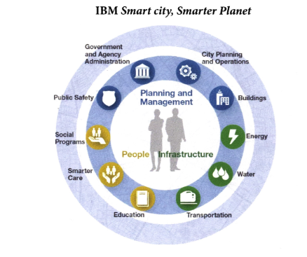

* 1. **Sensors**

PIR Sensor is short for passive infrared sensor, which applies for projects that need to detect human or particle movement in a certain range. It is also known as PIR (motion) sensor or IR sensor.

A passive infrared sensor is an electronic sensor that measures infrared light radiating from objects in its field of view. They are most often used in PIR-based motion detectors. PIR sensors are commonly used in security alarms and automatic lighting applications.

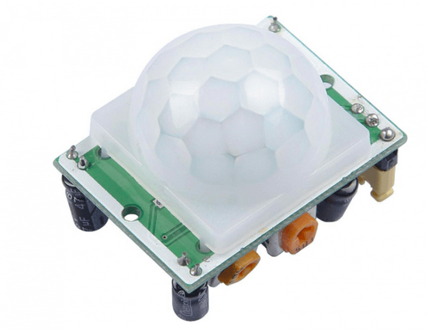

Generally, PIR can detect animal/human movement in a requirement range, which is determined by the spec of the specific sensor. The detector itself does not emit any energy but passively receives it, detects infrared radiation from the environment.

* 1. **WiFi**

Wi-Fi Door Lock with ESP32 CAM uses Internet of Things (IoT) technology to monitor the status of the door, control it, and improve home security. Blynk is a communication protocol that is used to increase the security of a home. Blynk is a communication protocol that connects a smartphone to a door lock system.  
The prototype is built using an iterative process that matches the design specifications during the development and implementation phase. We can create and test in repeating sequences by breaking down the design into little bits. New features can be developed and evaluated in each iteration until we have a fully functional system that meets the thesis's goals.

**SECTION III**

**ARCHITECTURE**

This section presents the overall structure of the implementation, block diagrams, and flowcharts will be shown in the following sections

* 1. **Diagram Block**

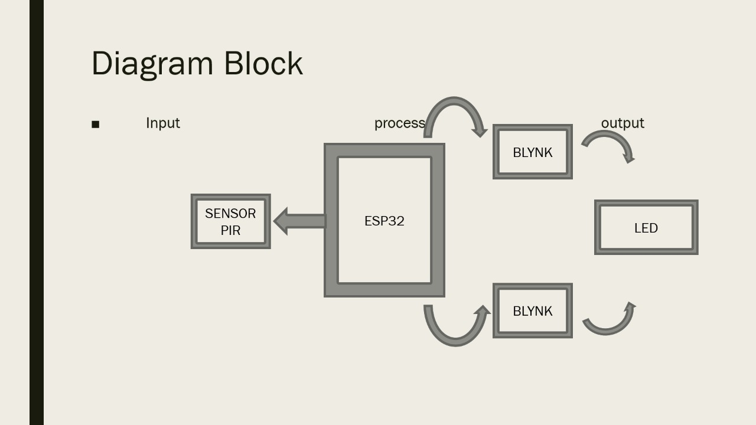

The block diagram above shows that the input for this project is using the PIR sensor. Then in the processing there are esp32 and the blynk application. For the output, there is a LED. So, ESP32 must connect with PIR sensor and blynk application. ESP32 and blynk is connected by using hotspot of blynk installed device.

* 1. **Flowchart**

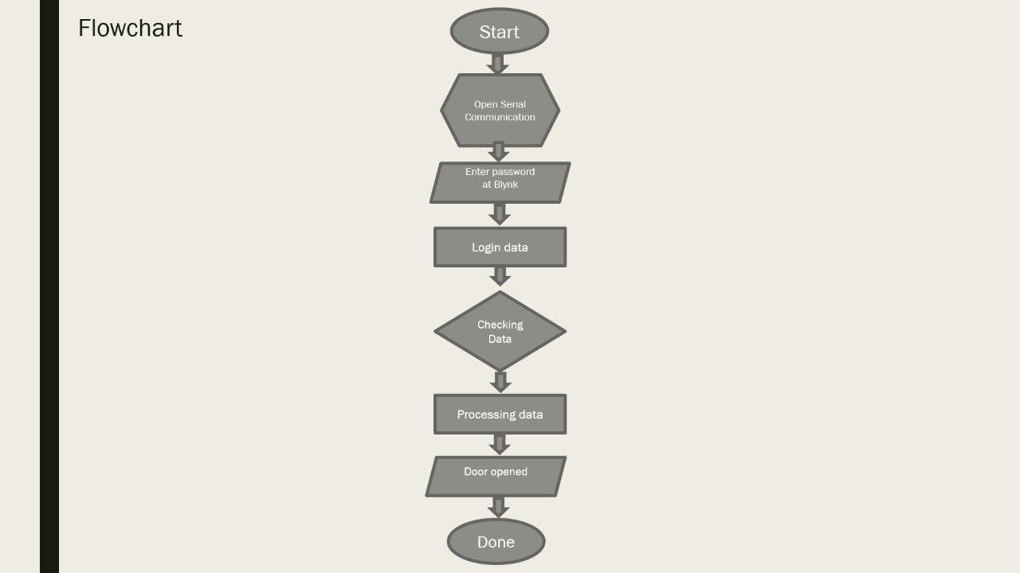

true

false

## The first thing that can be done by a user is to start it, this is indicated by the symbol ‘start’, which means the system is started. A flowchart always begins with ‘start’ and ends with ‘end’, ‘done’ or ‘finish’.

## On the hexagon symbol, it shows a preparation, based on the flowchart above, it prepared to open serial communication.

## When the user starts it, it will enter the main page, it is depicted by a parallelogram which means there is a process. So when we entered password at the blynk application, it will process it.

## For processing login data it uses rectangle.

## After login data, data will be checked.

## After checked, data will be processed.

## If data true, door will be opened.

## If data false, it will be back at entered password.

**BAB IV**

**IMPLEMENTATION**

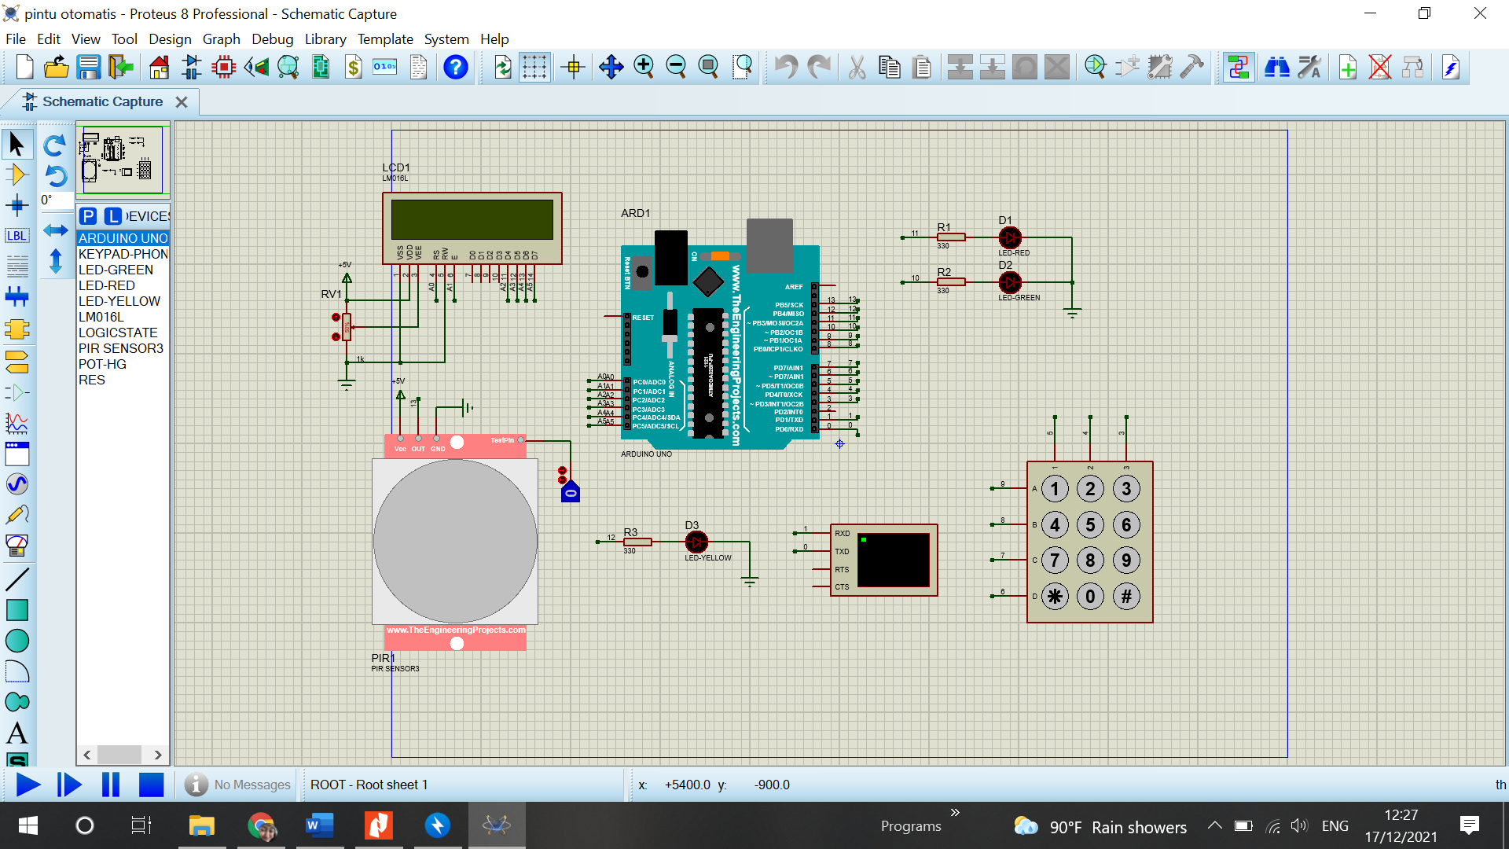

This is an image of a simulated door with a password using the Proteus application. Because in Proteus there is no Blynk, so here it is replaced using the keypad and LCD, and for the ESP32, it uses Arduino Uno. The components here using LCD, Arduino UNO, 4x4 keypad, LEDs, PIR sensors, resistors and potentiometers. At the input there is a PIR sensor and a keypad. And its output are LCD and LED. The way it works is by entering the password using the keypad, if the password is correct then the green LED will light up. If the password is incorrect then the red LED will light up. The correct or incorrect password will appear on the LCD. The LCD also connects to the PIR sensor to function as a motion sensor so that when we enter the room, the lights will automatically turn on. In the simulation above, the LED connected to the PIR sensor is a yellow LED, so if the sensor detects motion, the yellow LED will light up.

In this original circuit, the PIR sensor and LED were connected to the ESP32, then the ESP was connected using a smartphone with the Blynk application installed. the way it works is to enter the password in the blynk application, if the password is correct then the blue LED will light up and the LCD on the blynk will display "correct password", if the password is incorrect then the red LED will light up and the LCD on the blynk will display "wrong password". and when the pir sensor detects motion 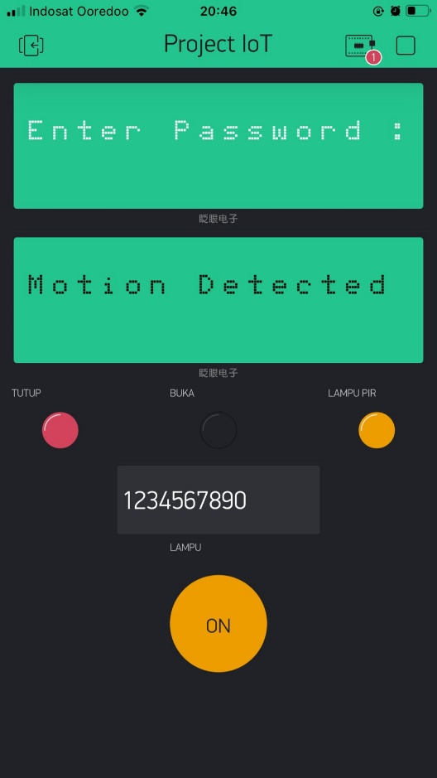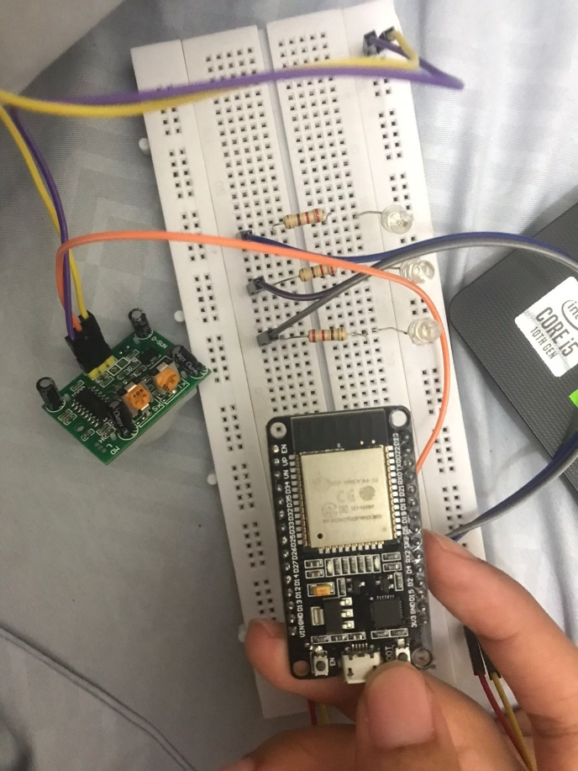then the white LED will light up.

# BAB V

**RESULTS**

From the results of this study, it can be concluded that if the password is correct then the Blynk application LCD shows "password is correct" and the LED will light up, where what is meant here is the door will open. and if the password is wrong then the Blynk application LCD will appear "wrong password" and the red LED will light up, which means that the door will not open and will return to "enter password". In this research, we use one PIR sensor, three LEDs, one ESP32, three resistors and some jumper cables.

**BAB VI**

**CONCLUSION**

# We successfully designed an IoT based Wi-Fi door lock security system using ESP32Cam to monitor door status and improve home security. The Blynk communication protocol is used between the smartphone and the door lock system. Moreover, the model we propose in this paper can be extended by integrating smart doors, which can be used to trigger system to open and close the door automatically according to various ways such as by regulating the temperature or others. Settings and configuration of Arduino UNO and other relevant modules, such as those proposed for motion detection and automatic switches form the basis for the extended model idea. In addition, android apps should be able to manage more doors, windows and basic home electronics in futures. To ensure the completeness of the system, a battery backup system should be considered.

# REFRENCE

Pavelić, Marko, et al. "Internet of things cyber security: Smart door lock system." 2018 international conference on smart systems and technologies (SST).  
IEEE, 2018

D. Han, H. Kim, and J. Jang, “Blockchain-based smart door lock system,” Proceedings of IEEE International Conference on Information and Communication Technology Convergence (ICTC), 2017, pp. 1165-1167

D. Liu, et al, “A novel heading estimation algorithm for pedestrian  
using a smartphone without attitude constraints,” IEEE UPINLBS  
2016, Shanghai, China, Nov 3-4, 2016, pp. 29-37.